|  |  |  |  |
| --- | --- | --- | --- |
| **Course Code:** | **ECE1002** | **Course Name:** | **Semiconductor Devices and Circuits Lab** |
| **Faculty In – Charge:** | **Dr. Pradeep Naryanan. S.** | **Department:** | **SENSE** |
| **Name of the Student:** | **Aryan Pandey** | **Registration Number:** | **20BLC1087** |
| **Experiment No.:** | **2** | **Date of Experiment:** | **08.03.2021** |
| **Name of the Experiment:** | **DESIGN AND VERIFICATION OF ZENER DIODE** | | |

**OBJECTIVE:**

To design and verify the function of the Zener diode using LTSPICE Simulator and observe its V-I characteristics.

**TOOLS:**

LTSPICE XVII Simulator.

**THEORY**

**ZENER DIODE: -**

Zener diode is basically like an ordinary PN junction diode but normally operated in reverse biased condition. A Zener Diode, also known as a breakdown diode, is a heavily doped semiconductor device that is designed to operate in the reverse direction. When the voltage across the terminals of a Zener diode is reversed and the potential reaches the Zener Voltage (knee voltage), the junction breaks down and the current flows in the reverse direction. This effect is known as the *Zener Effect*. Zener Diode symbol and how it is connected in Reverse Bias position in a circuit is shown below -

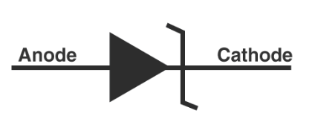

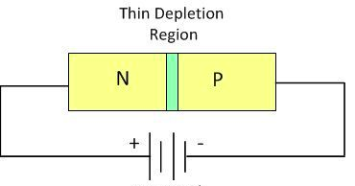

**FORWARD BIAS: -**

The Zener Diode is like a general-purpose signal diode. In forward bias mode it behaves like a normal Diode but normally it is not used in forward direction.

The Zener Diode operates just like the normal diode when in the Forward Bias mode, and has a turn-on voltage of between 0.3 and 0.7 V.

If a suitable positive voltage is applied between the two ends of the PN junction, it can supply free electrons and holes with the extra energy they require to cross the junction as the width of the depletion layer around the PN junction is decreased.

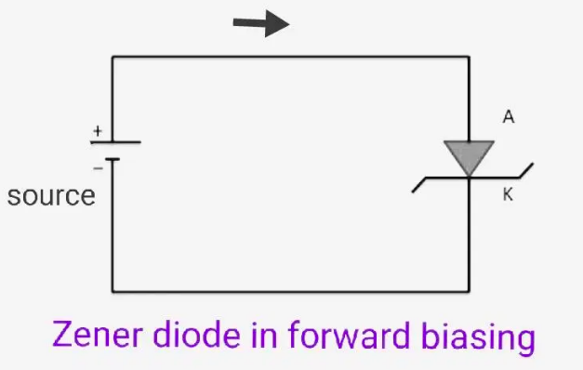

**REVERSE BIAS: -**

A Zener Diode is always operated in its reverse biased condition. As such a simple voltage regulator circuit can be designed using a Zener Diode to maintain a constant DC output voltage across the load in spite of variations in the input voltage or changes in the load current.

By applying a negative voltage results in the free charges being pulled away from the junction resulting in the depletion layer width being increased. This has the effect of increasing or decreasing the effective resistance of the junction itself allowing or blocking current flow through the diode.

Then the depletion layer widens with an increase in the application of a reverse voltage and narrows with an increase in the application of a forward voltage. This is due to the differences in the electrical properties on the two sides of the PN junction resulting in physical changes taking place. One of the results produces rectification as seen in the PN junction diodes static I-V (current-voltage) characteristics.

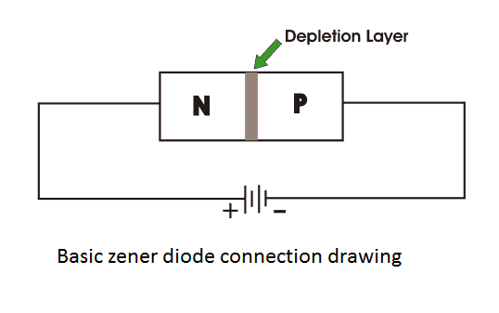

**PROCEDURE**

**Forward Voltage: -**

1. Open LT Spice and select the new schematic button to draw a new circuit. Click on the component symbol and select a Voltage Source place it in the required position from the component option.
2. Add a Resistor to the diagram by selecting and dragging it to the required position from the components option.
3. Add a Diode to your diagram in the same way. For this right click the Diode. Click on pick a new diode. Select the required Zener Diode.
4. The positive of the voltage source should be connected to positive of the Zener Diode for forward bias.
5. Now we need to join the components together to build a circuit. Select the wire component from the top menu and join the components. Don’t forget to add a ground to your circuit.
6. Next step is to specify values for your components. Right-click on the resistance and provide the required values. In our experiment let’s take it as 1KΩ.
7. Now pick the diode by right-clicking on the diode symbol. Select the option “**pick new diode**” and select the required Zener Diode from the pop-up list.
8. Now the final step to select your voltage source with 5V.
9. Now finally we need to run our circuit to see the output. In order to do this, we need to click on the run button on the top menu. Select the “DC sweep” tab from the popup menu.
10. Now provide the required values: -
11. Voltage source - V1
12. Type of sweep - Linear
13. Start value = 0
14. Stop value = 10
15. Increment = 0.02

Click OK button.

1. Right click on the plane graph after running the simulation. Click on add traces and select ID1 which is the current flowing through the diode.
2. Then copy the ID1 as it is in the traces window. Later right click on the x axis and paste it in “quantity plotted portion” to obtain the exponential graph correctly as per our analysis.
3. Right click again and select add traces then click on V(Vout).
4. Then copy the V(Vout) as it is in the traces window. Later right click on the x axis and paste it in “quantity plotted portion” to obtain the graph correctly as per our analysis.
5. Now you will have a screen with two windows. One is a graph and the other is a circuit.
6. We need to plot the characteristics. To find the current, click on the diode symbol.

**Reverse Voltage: -**

1. Open LT Spice and select the new schematic button to draw a new circuit. Click on the component symbol and select a voltage source place it in the required position from the component option.
2. Add a Resistor to the diagram by selecting and dragging it to the required position from the components option.
3. Add a diode to your diagram in the same way. For this right click the diode. Click on pick a new diode. Select the required Zener Diode. (BZX84C12L)
4. The positive of the voltage source should be connected to positive of the Zener Diode for forward bias.
5. Now we need to join the components together to build a circuit. Select the wire component from the top menu and join the components. Don’t forget to add a ground to your circuit.
6. Next step is to specify values for your components. Right-click on the resistance and provide the required values. In our experiment let’s take it as 1KΩ.
7. Now pick the diode by right-clicking on the diode symbol. Select the option “**pick new diode**” and select the required Zener Diode from the pop-up list. (BZX84C12L)
8. Now the final step to select your voltage source with 5V.
9. Now finally we need to run our circuit to see the output. In order to do this, we need to click on the run button on the top menu. Select the “DC sweep” tab from the popup menu.
10. Now provide the required values: -

* Voltage source - V1
* Type of sweep - Linear
* Start value = -10
* Stop value = 0
* Increment = 0.01.

Click OK button.

1. Right click on the plane graph after running the simulation . click on add traces and select ID1 which is the current flowing through the diode.
2. Then copy the ID1 as it is in the traces window. Later right click on the x axis and paste it in “quantity plotted portion” to obtain the exponential graph correctly as per our analysis.
3. Right click again and select add traces then click on V(Vout).
4. Then copy the V(Vout) as it is in the traces window. Later right click on the x axis and paste it in “quantity plotted portion” to obtain the graph correctly as per our analysis.
5. Now you will have a screen with two windows. One is a graph and the other is a circuit.
6. We need to plot the characteristics. To find the current, click on the diode symbol.

**VERIFICATION OF ZENER DIODE**

1. **Forward Voltage: -**
2. For forward bias of Zener diode we use - BZX84C12L

As our Zener diode in forward biasing: -

The first quadrant in the graph represents the forward characteristics of a Zener diode. From the graph, we understand that it is almost identical to the forward characteristics of any other p-n junction diode.

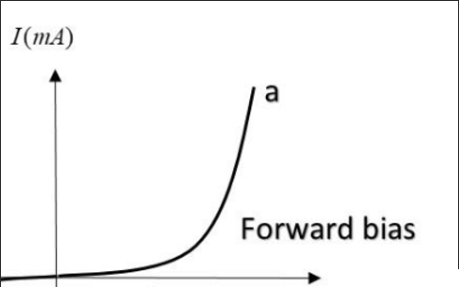

**Components Required: -**

* Voltage Source
* Resistor
* Wire,
* Ground
* A specific Zener Diode arranged in forward bias.

**Resistor Values Tested: -**

* + 5 OHMS
  + 10 OHMS
  + 100 OHMS
  + 1000 OHMS..(most appropriate)
  + 10000 OHMS

**Logic Diagram: -**

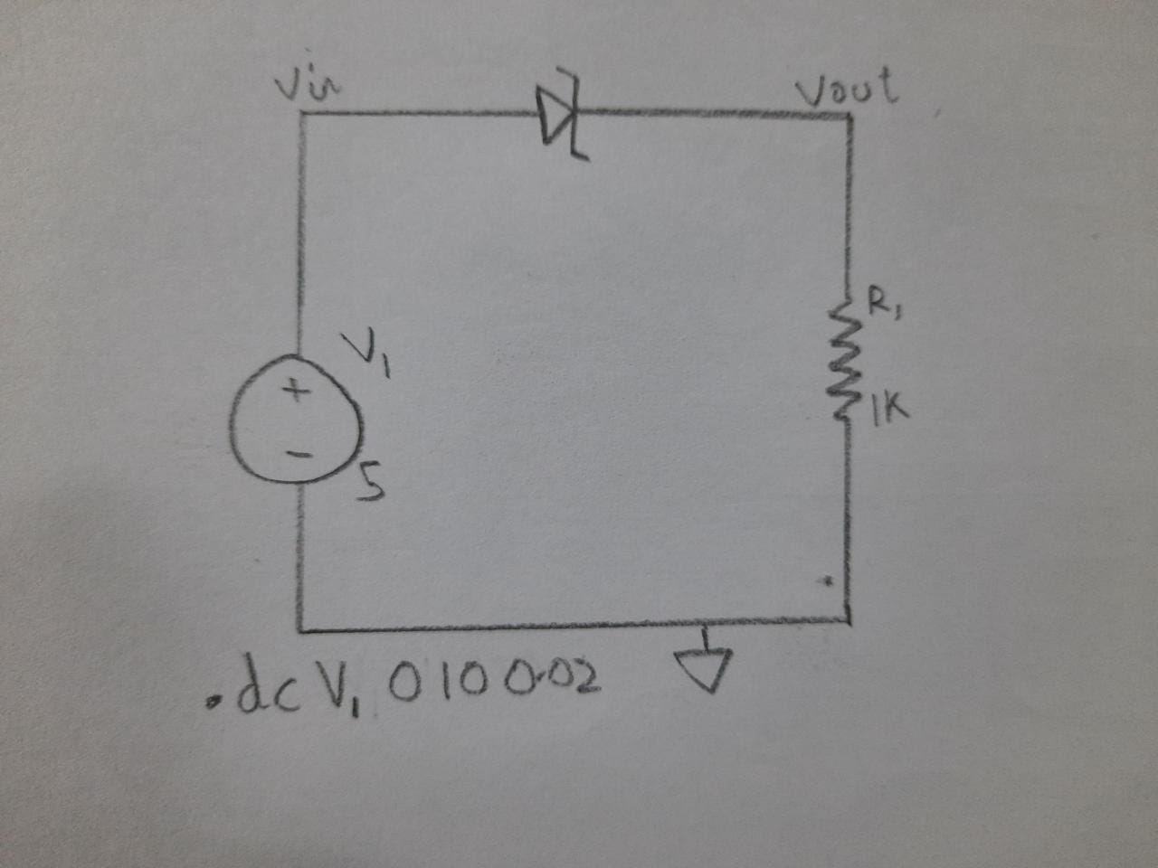

**Simulator Diagram - Schematic: -**

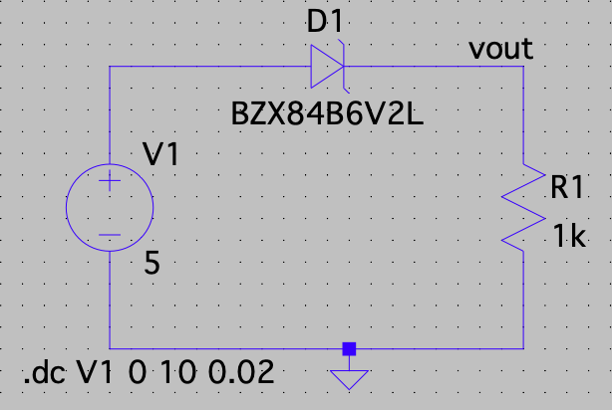

**Output Waveform: -**

**Input Waveform near Zener (Voltage): -**

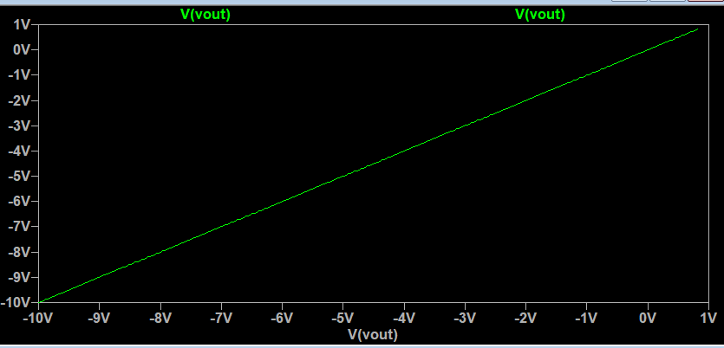

**Output wave form near Zener (Current through Zener): -**

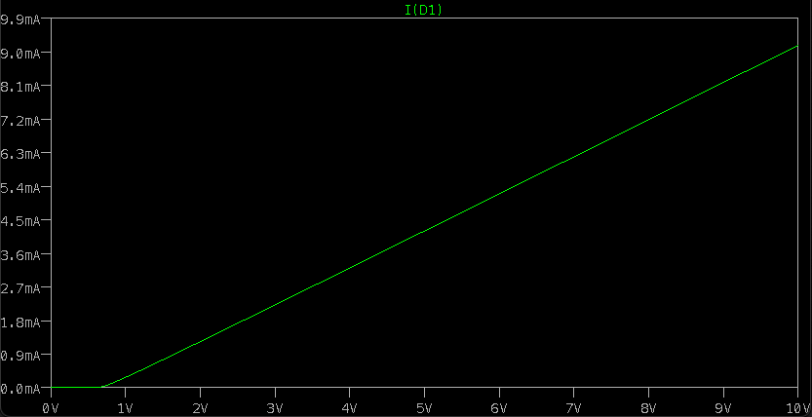

**Output Waveform near Zener (Voltage): -**

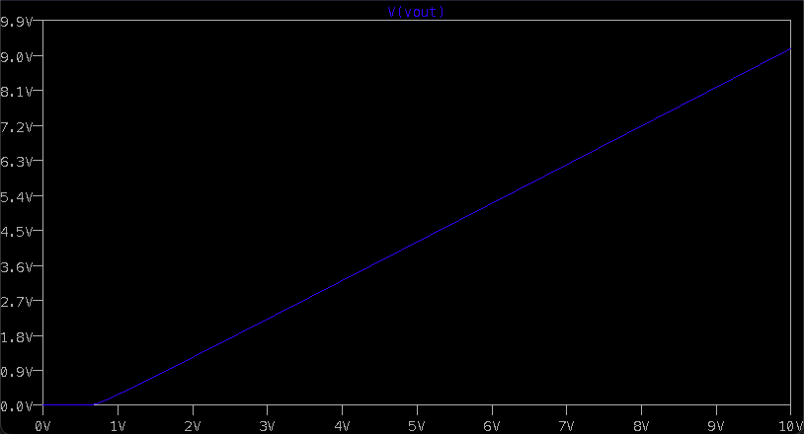

**Reverse Voltage: -**

When a reverse voltage is applied to a Zener Voltage, initially a small reverse saturation current Io flows across the diode. This current is due to thermally generated minority carriers. As the reverse voltage is increased, at a certain value of reverse voltage, the reverse current increases drastically and sharply. This is an indication that the breakdown has occurred. We call this voltage breakdown voltage or Zener Voltage and it is denoted by VZ.

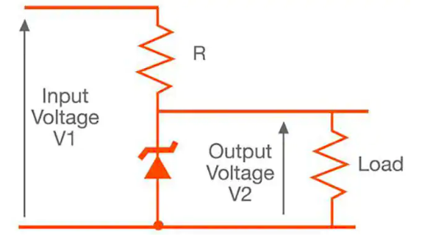

**Components Required: -**

* + Voltage Source
  + Resistor
  + Wire
  + Ground
  + A specific Zener Diode arranged in Reverse Bias.

**Resistor values tested: -**

* + 5 OHMS
  + 10 OHMS
  + 100 OHMS
  + 1000 OHMS..(most appropriate)
  + 10000 OHMS

**Logic Diagram: -**

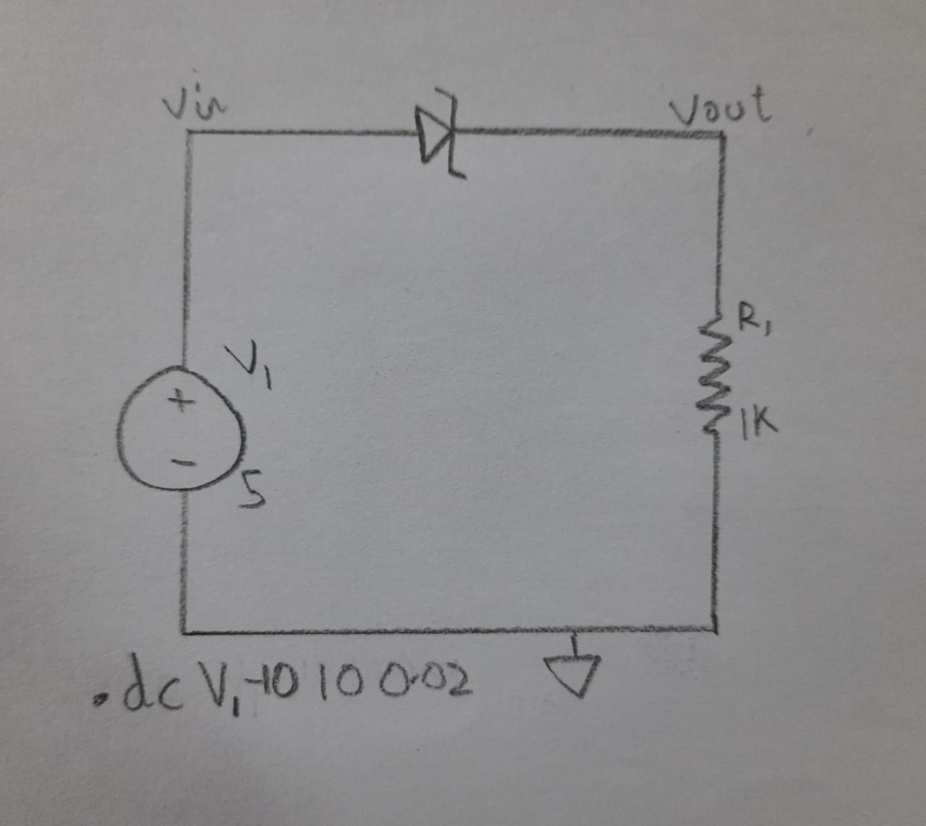

**Simulator Diagram – Schematic (Observe the Range): -**

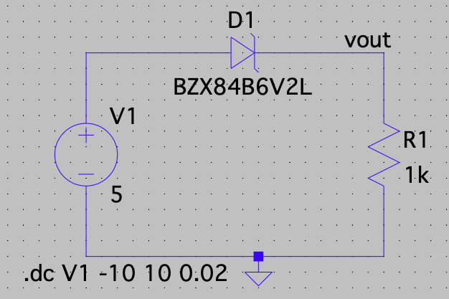

**Output Waveform: -**

**Input waveform near Zener (Voltage): -**

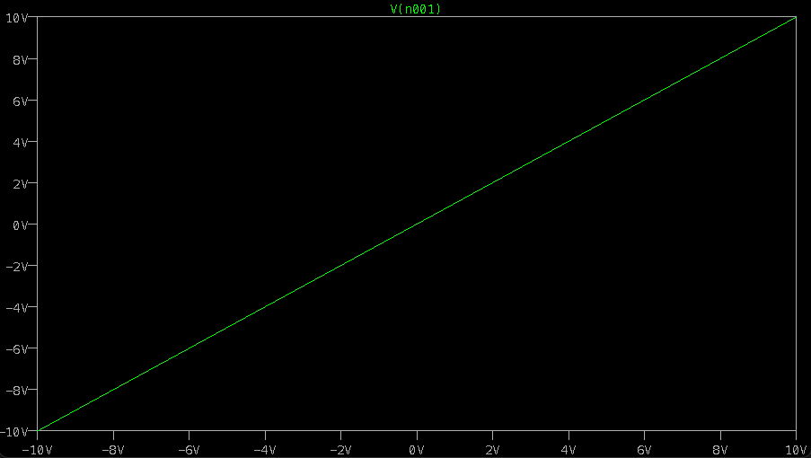

**Output waveform near Zener (Voltage): -**

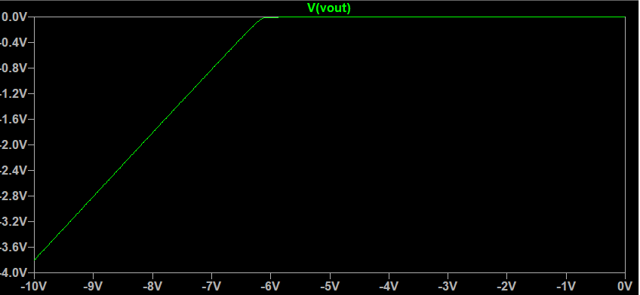

**Output Current near the Zener Diode: -**

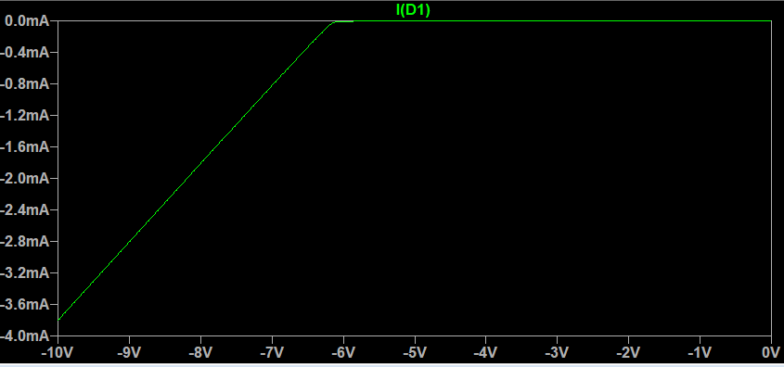

**Total Zener Diode Characteristics Graph on LT Spice on Forward Bias: -**

**For this change the DC Simulation ‘Start’ and ‘End’ Value to be from -10V to 10V: -**

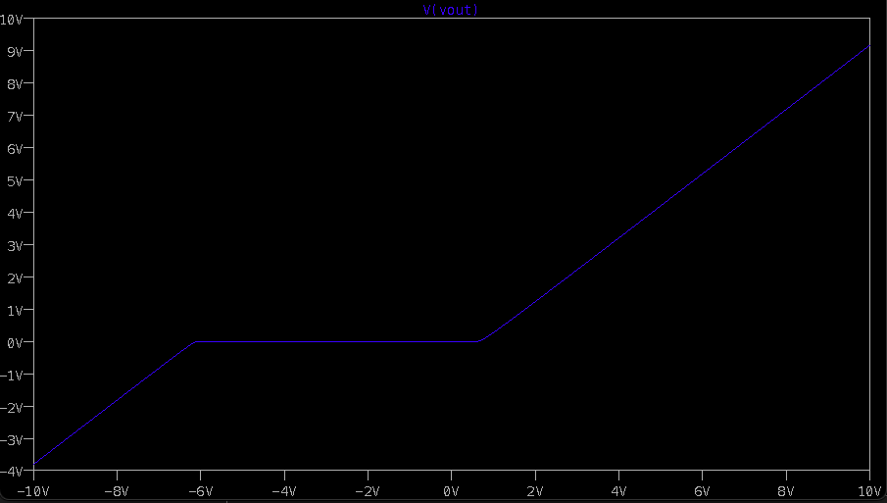

**INFERENCE**

The VI characteristic graph of the Zener Diode is shown in the figure below. This curve shows that the Zener Diode, when connected in forward bias, so it behaves like an ordinary diode but when the reverse voltage applies across it and the reverse voltage rises beyond the predetermined rating, the Zener breakdown occurs in the diode.

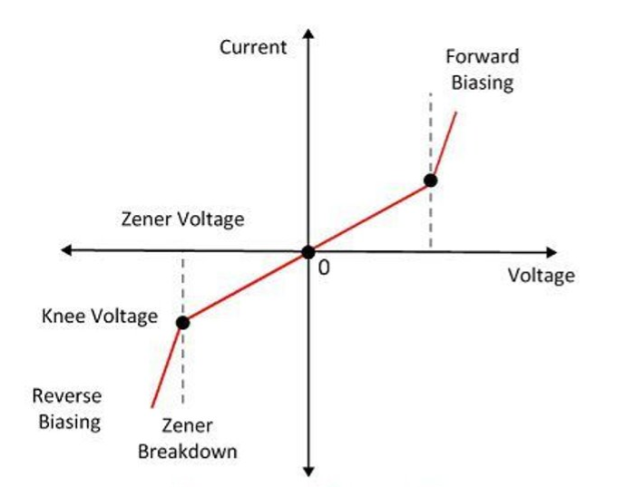

At Zener breakdown voltage the current starts flowing in the reverse direction. ​

​

The graph of the Zener breakdown is not exactly vertical shown above which shows that the Zener diode has resistance. ​

​

The voltage across the Zener is represented by the equation shown below.​

​

V = VZ + IZRZ​

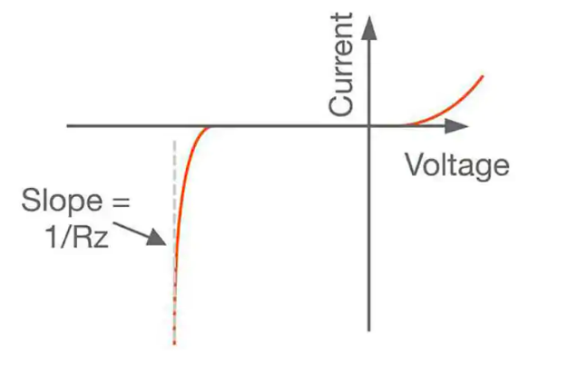

**The V-I Characteristics of a Zener Diode can be divided into two parts: -**

1. Forward Characteristics
2. Reverse Characteristics

**Forward Characteristics: -**

The forward characteristics of a Zener diode is shown in figure. It is almost identical to the forward characteristics of a P-N junction diode.

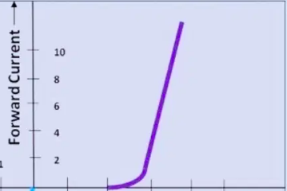

**Reverse Characteristics: -**

As we increase the reverse voltage, initially a small reverse saturation current Io. Which is in  A,  will follow. This current  flows due to the thermally generated minority carriers. At a certain value of reverse voltage, the reverse current will increase suddenly and sharply . This is an indication that the breakdown has occurred. This breakdown voltage is called as Zener breakdown voltage or Zener voltage and it is denoted by Vz.

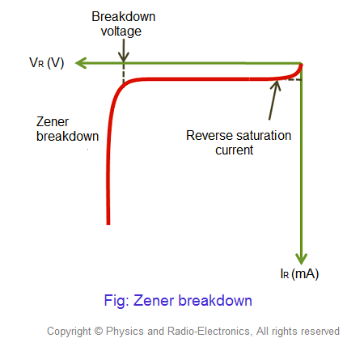

The value of Vz can be precisely controlled by controlling the doping levels of P and N  regions at the time of manufacturing a Zener diode. After breakdown has occurred. The voltage across Zener diode remains constant equal to Vz. Any increase in the source voltage will result in the increase in reverse Zener current. The Zener current after the reverse breakdown must be controlled by connecting a resistor R as shown in figure.

This is essential to avoid any damage to the device due to excessive heating.

Also observe the cut off voltage which is nearly at -6 which matches our diode characteristics.

**RESULT: -**

**The VI characteristics of Zener Diode in Forward and Reverse Bias using LT Spice has been successfully verified.**